1. download the project tess-two from

https://github.com/rmtheis/tess-two

1. cd <project-directory>/tess-two

ndk-build

1. import the project as a library in Eclipse. File -> Import -> Existing Projects into workspace -> tess-two directory. Right click the project, Android Tools -> Fix Project Properties. Right click -> Properties -> Android -> Check Is Library.

*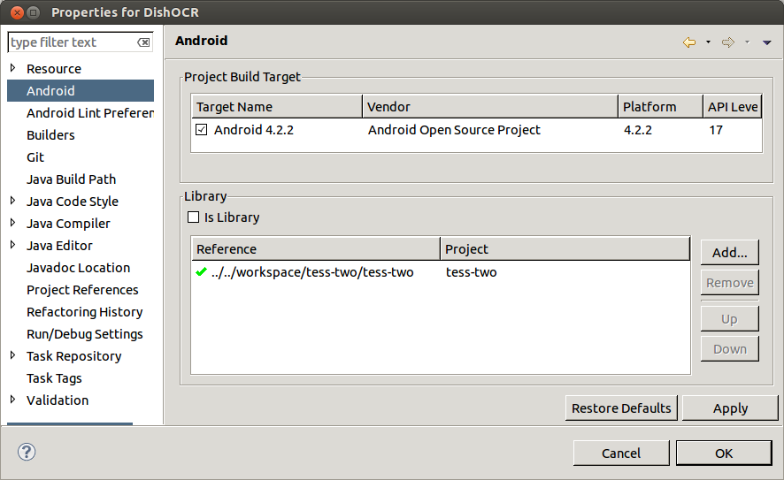*

1. Configure your project to use the tess-two project as a library project: Right click your project name -> Properties -> Android -> Library -> Add, and choose tess-two. You’re now ready to OCR any image using the library.
2. Make sure the tess-two.jar is available after “ndk-build”
3. That's it!